**DOCKER PUSH IMAGE**

Pushing a Docker image involves uploading it from your local environment to a container registry.

**Create EC2 instance and deploy Docker.**

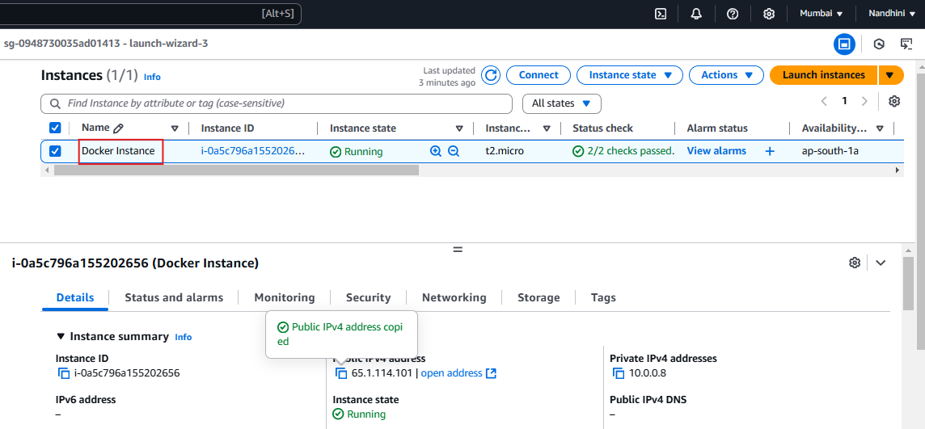

**Log In to the Registry,**

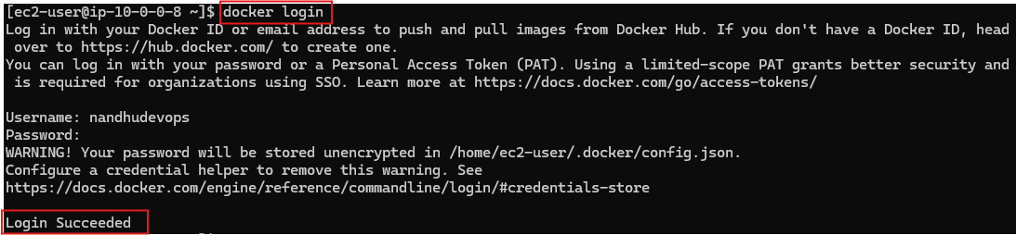

**Create a repository in Docker hub to push the container.**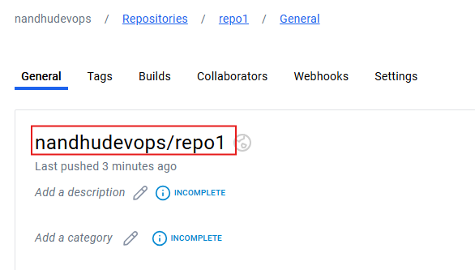

**Before pushing,**

Container to be converted into images.

Check whether the image is tagged with the target registry and repository name.

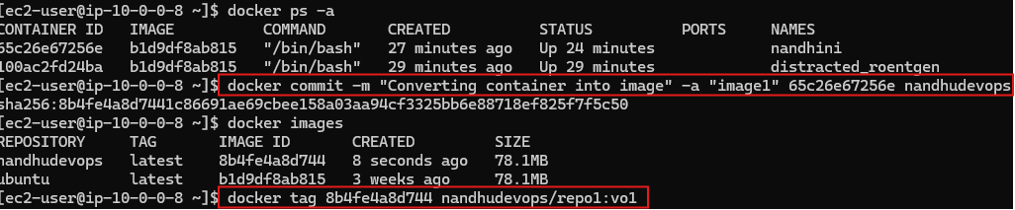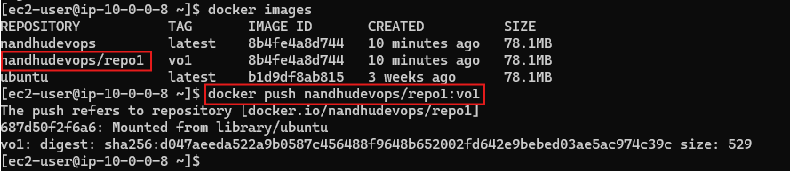

**Successfully pushed images into particular repository.**

